**REST - Country Web Service**   
  
Write a REST service that returns India country details in the earlier created spring learn application.  
  
**URL**: /country  
**Controller**: com.cognizant.spring-learn.controller.CountryController  
**Method Annotation**: @RequestMapping  
**Method Name**: getCountryIndia()  
**Method Implementation**: Load India bean from spring xml configuration and return  
**Sample Request**: http://localhost:8083/country  
**Sample Response**:

{

  "code": "IN",

  "name": "India"

}

SME to explain the following aspects:

* What happens in the controller method?
* How the bean is converted into JSON reponse?
* In network tab of developer tools show the HTTP header details received
* In postman click on "Headers" tab to view the HTTP header details received

**SpringLearnApplication.java**

package com.cognizant.springlearn;

import org.springframework.boot.SpringApplication;

import org.springframework.boot.autoconfigure.SpringBootApplication;

@SpringBootApplication

public class SpringLearnApplication {

public static void main(String[] args) {

SpringApplication.run(SpringLearnApplication.class, args); }

}

**Output:**

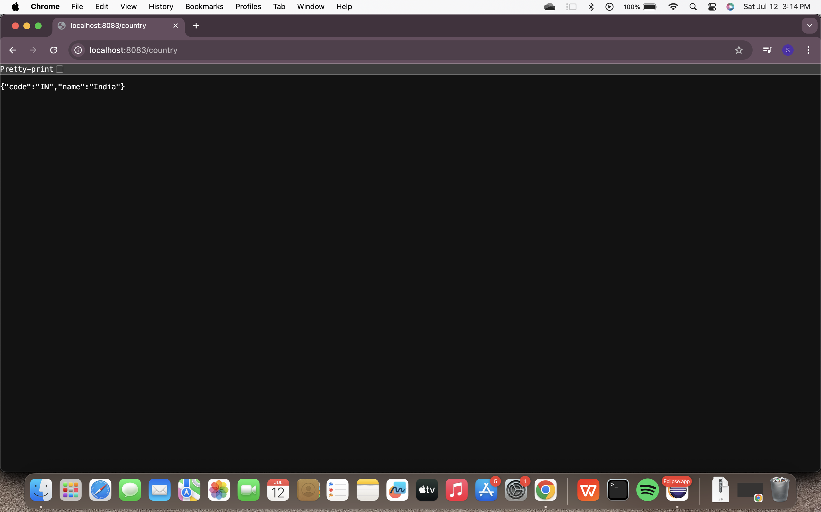

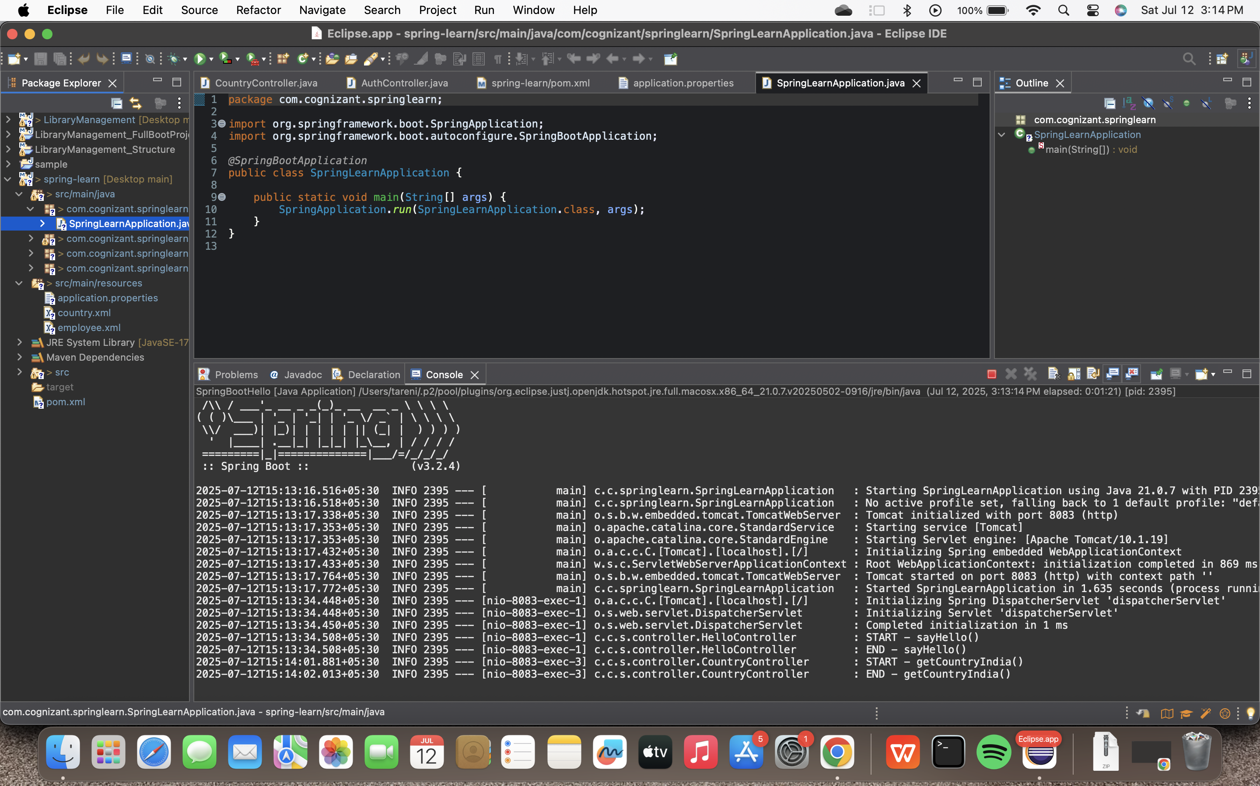

**SME:**

### What happens in the controller method?

The method getCountryIndia():

Logs the start.

Loads Spring configuration from country.xml.

Fetches the bean with ID "in" (which represents India).

Returns the Country object (Spring converts it to JSON automatically).

Logs the end.

### How is the bean converted to JSON?

Spring Boot uses **Jackson** (a JSON library) behind the scenes.

Any object returned from a @RestController method is automatically **serialized to JSON** if:

It is a Java object.The controller is annotated with @RestController or @ResponseBody.

### HTTP Headers: Chrome Developer Tools

In the **Headers** tab:

**Response Headers**:

Content-Type: application/json

Content-Length: ...

Date: ...

**Request Headers**:

GET /country HTTP/1.1

User-Agent: ...

Accept: application/json

### HTTP Headers: Postman

Open Postman

Set method: GET

URL: http://localhost:8083/country

Click **Send**

Go to **Headers** tab in response:

You will see response headers like:

Content-Type: application/json

Content-Length

Date